Compsci 557 Homework 5

Kayla Goetzke

Phil Sauvey

Chapter 8 Questions

1)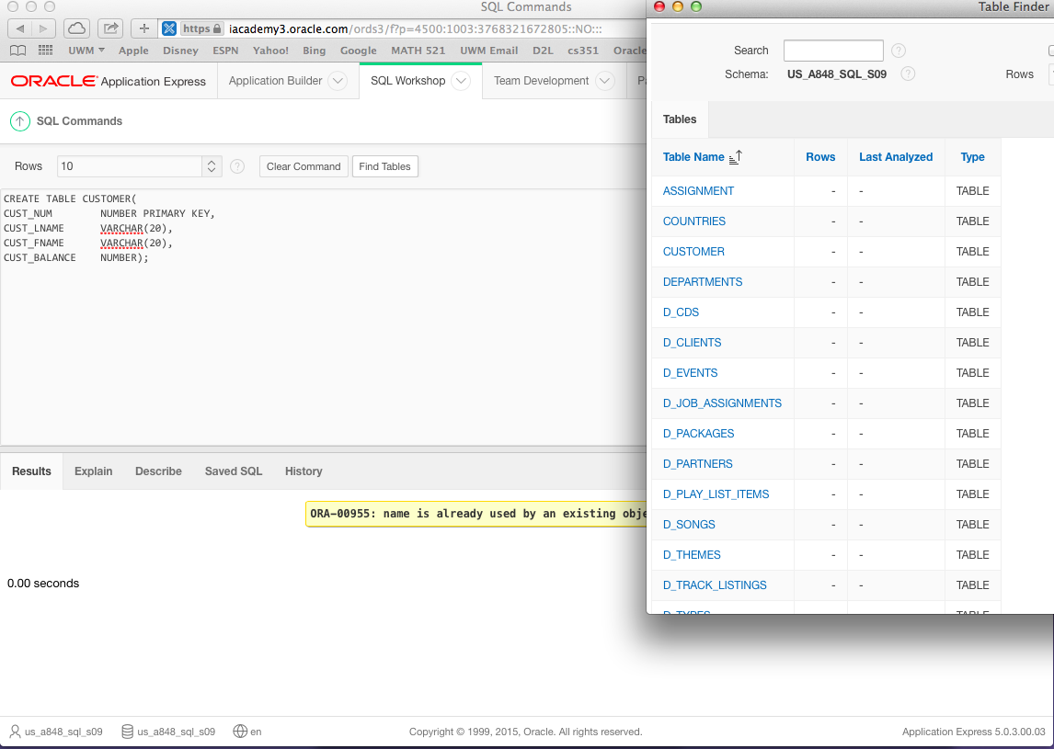

I forgot to take a screenshot before I created the next table, so I pulled up the tables to show you it was created.

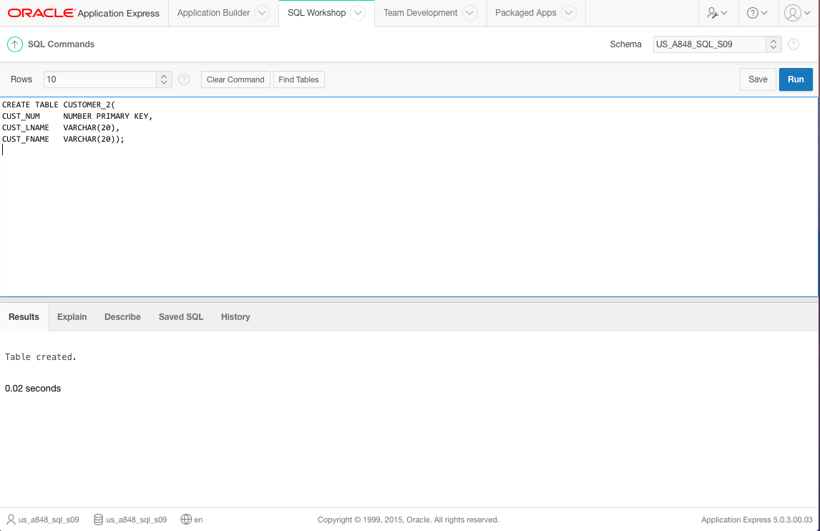

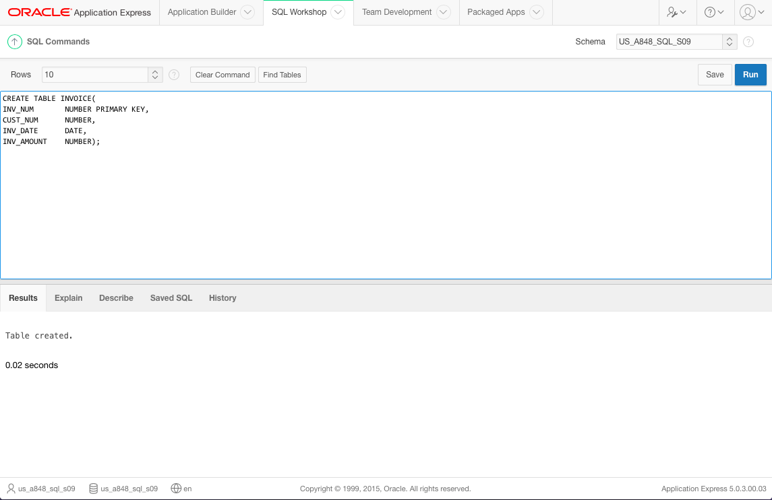

2)

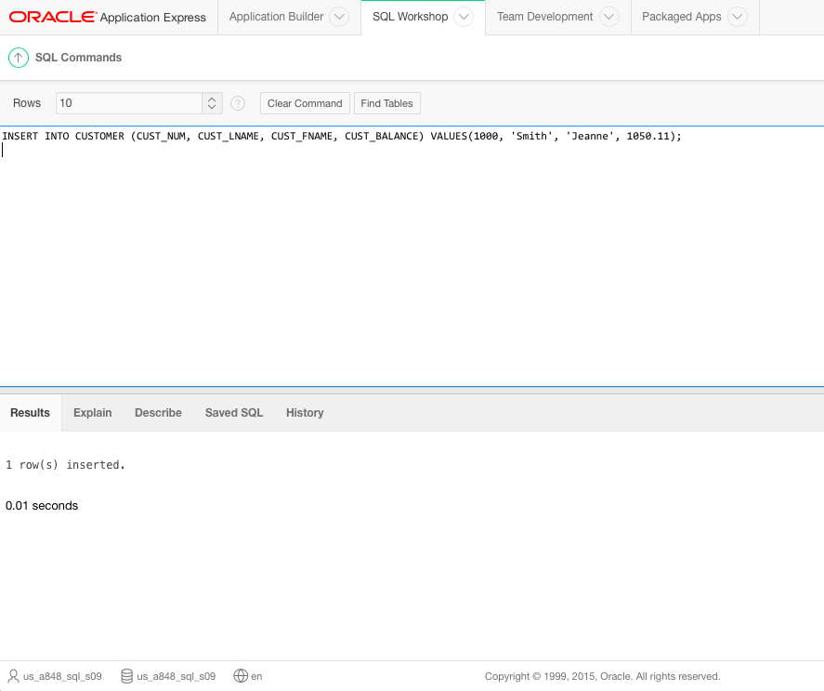

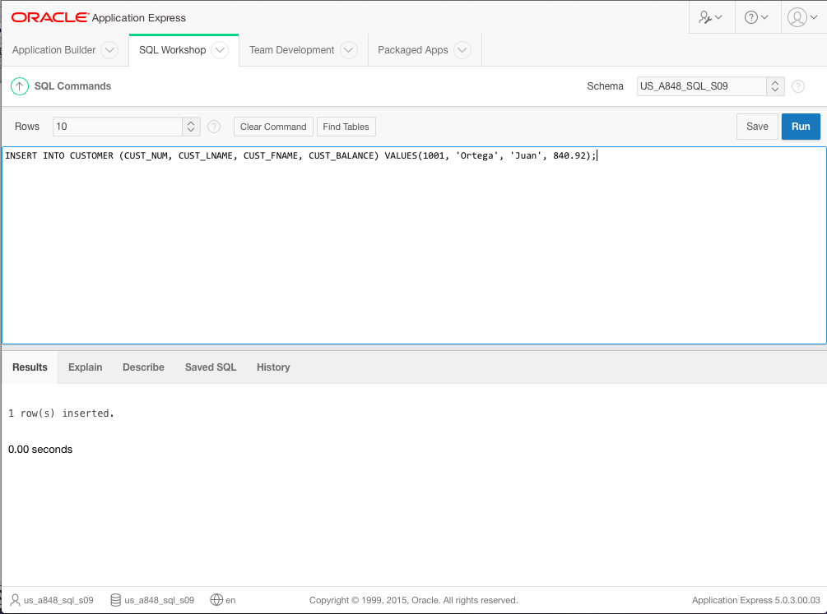

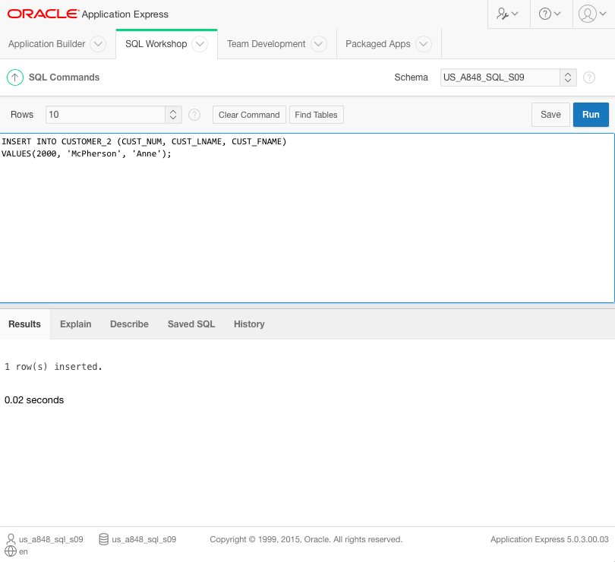

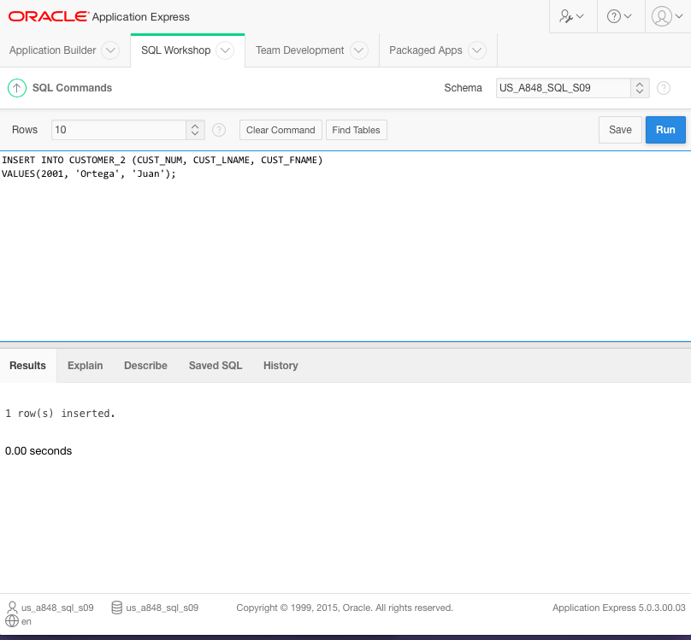

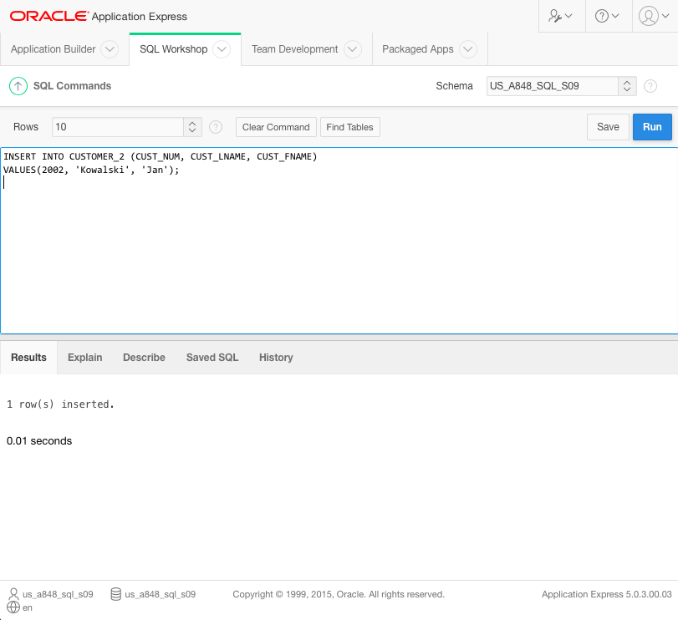

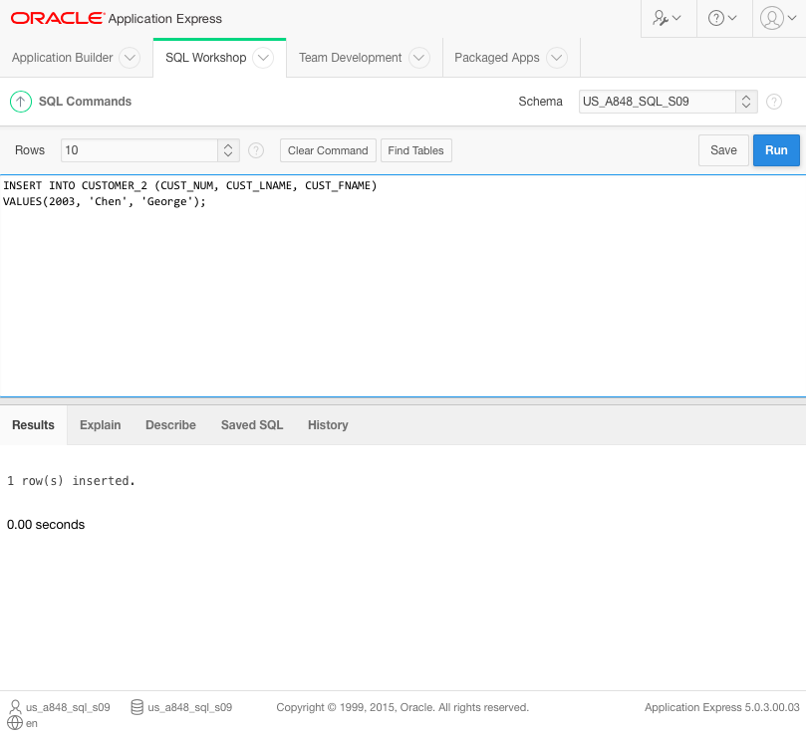

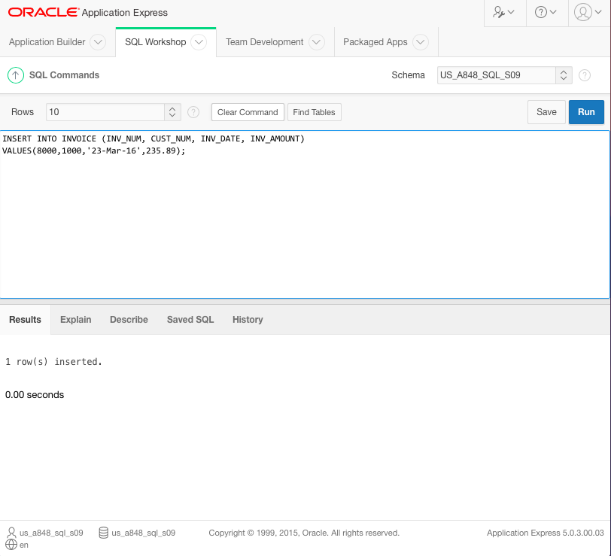

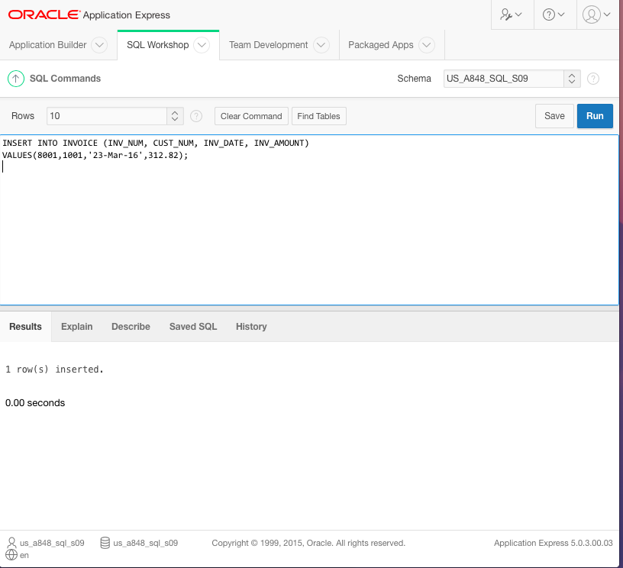

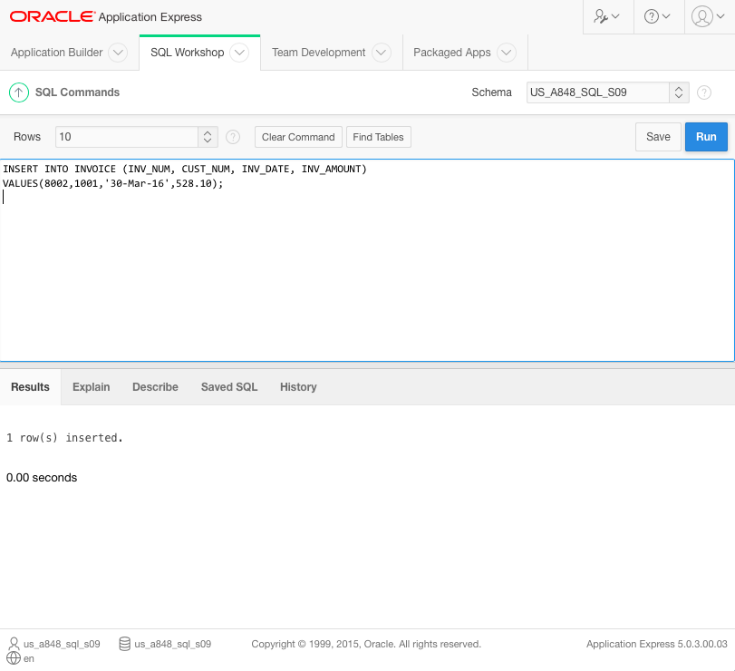

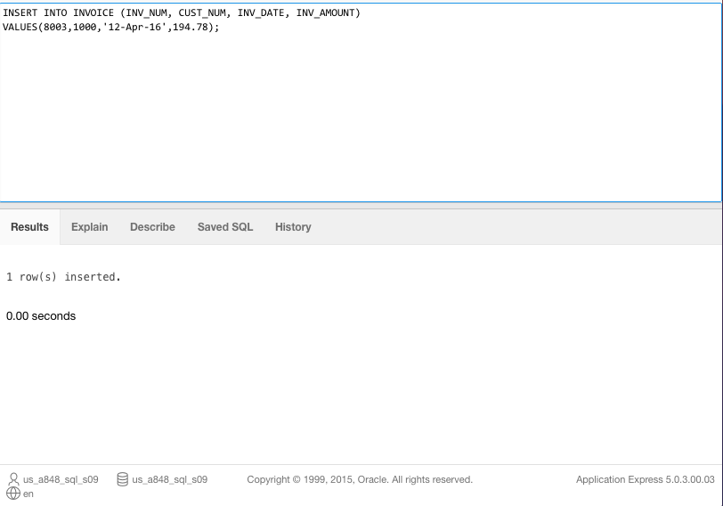

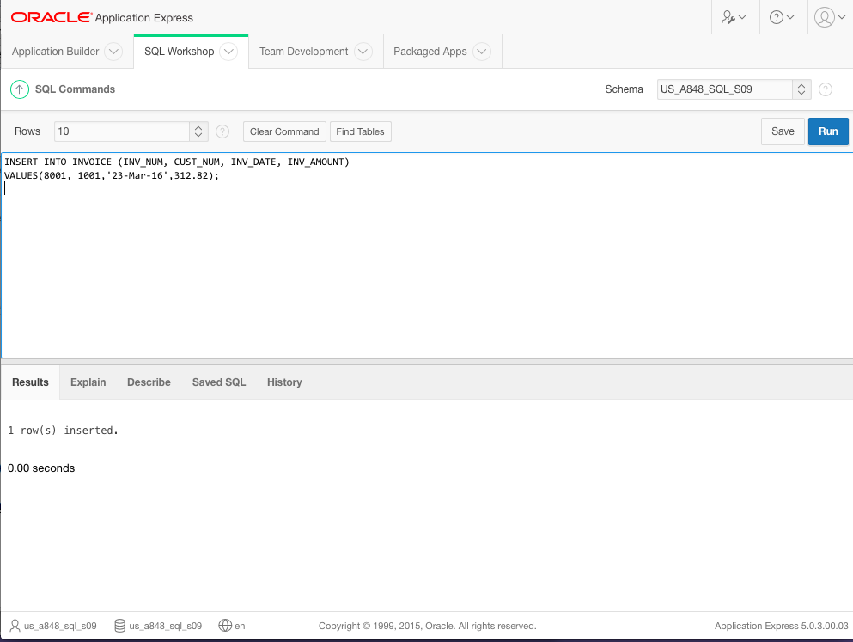

3)

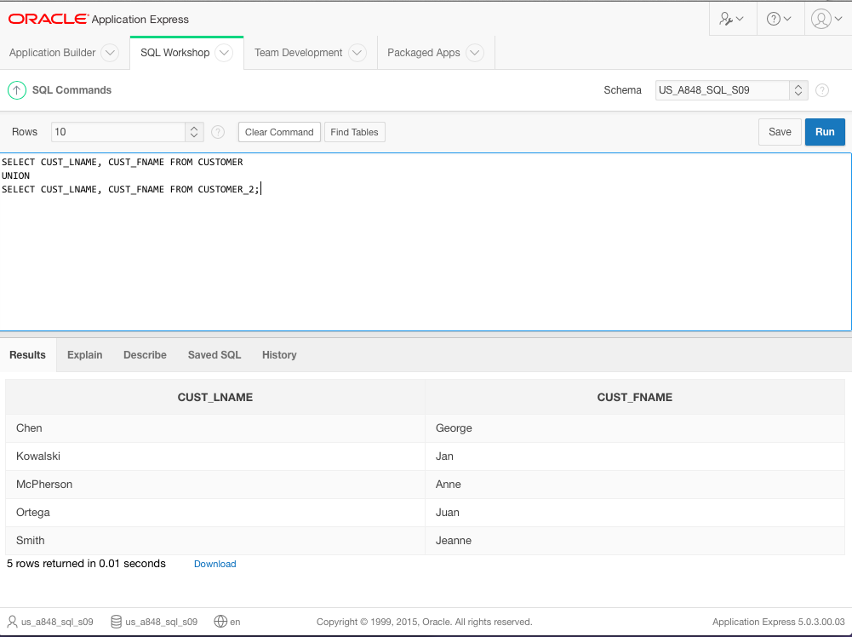

4)

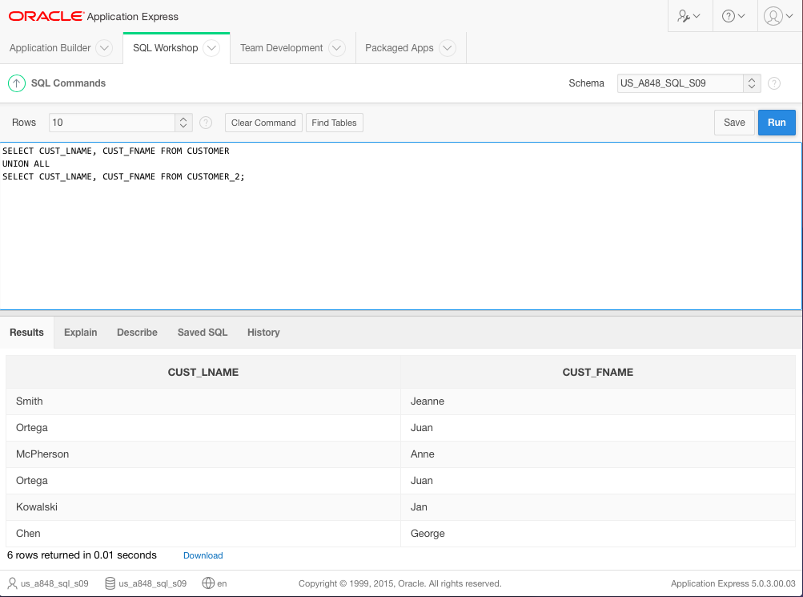

5)

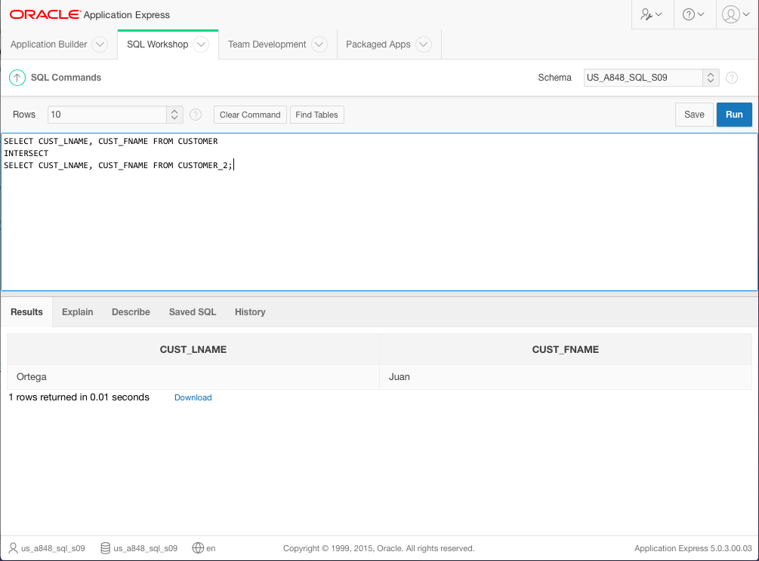

6)

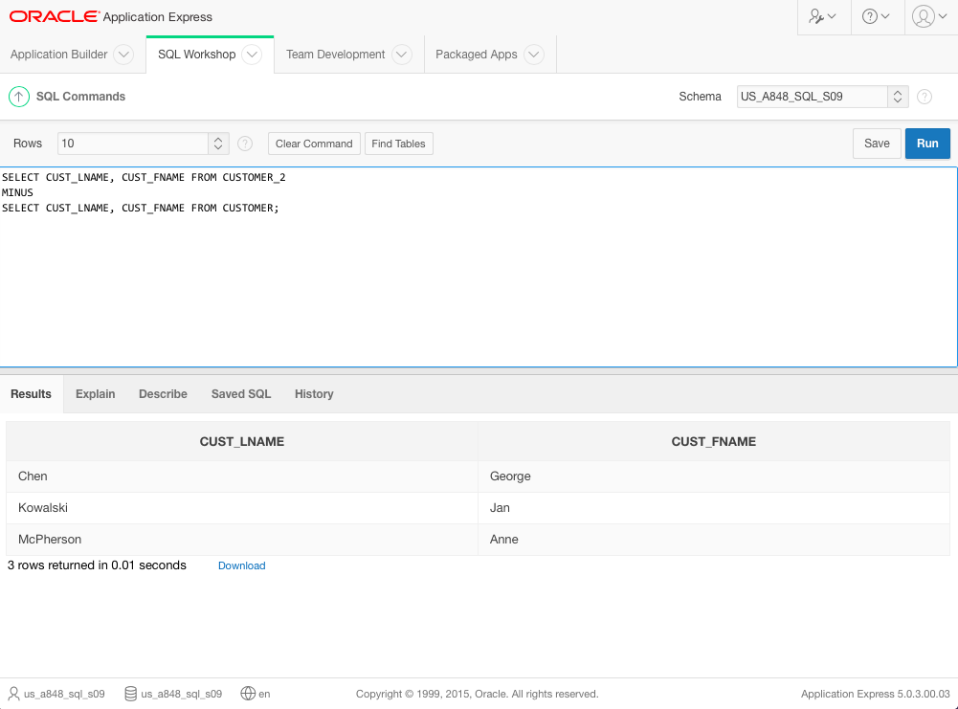

7)

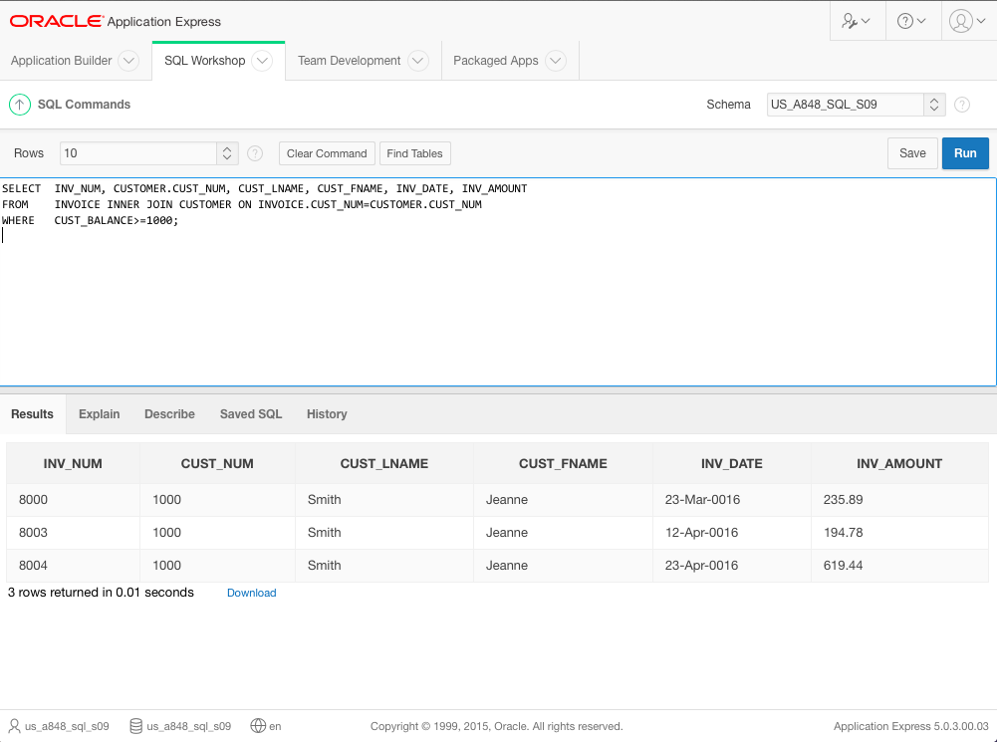

8)

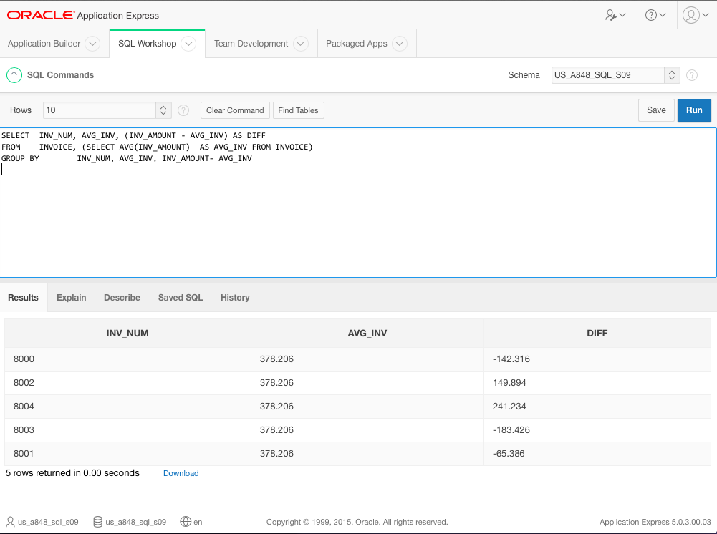

10)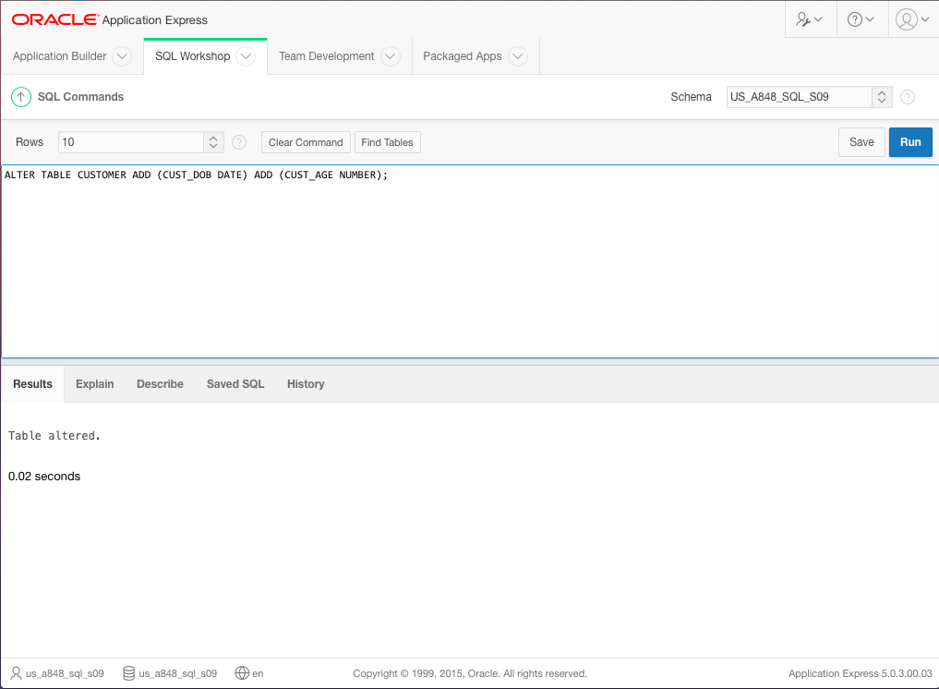

Chapter 9 Questions

1a)

7. Normalize the conceptual model

1. Obtain a general description of company operations.

9. Load the database.

4. Create a description of each system process.

11. Test the system.

5. Draw a data flow diagram and system flow charts.

6. Create a conceptual model using ER diagrams.

10. Create the application programs.

3. Interview the mechanics.

8. Create the file (table) structures.

2. Interview the shop manager.

1b)

The system should probably have inventory, accounting, and service modules. The inventory module will be responsible for keeping updated inventory as well as ordering replacement parts for lost stock. The accounting module will handle employees hours and payroll as well as handling customer invoicing/billing, and payments for part purchase requests. The service module will keep track of vehicle history, repairs performed and requesting parts from inventory .

1c)

A data dictionary contains database metadata, including at least all of the attribute names and characteristics for each table, which allows a team developers to ensure everyone is on the same page with regards to what belongs in a table, which reduces the chance of having duplicate data in multiple tables that can potentially cause problems when updating data.

1d)

I would recommend that the system be set up with several different permission/access groups to limit what users can and cannot see. The mechanics do not need to see the payroll information for all employees just like the accountant does not need to see service requests. I would also recommend creating a set of standard repairs and repair costs that can easily be added by the mechanics, Routine things like oil change, tire rotation, things of that nature, to speed along the routine operations. I would also probably recommend keeping track of which mechanic performed specific repairs in the event that there is an issue down the line.

1e)

A top down approach to database design is the best. Starting from very high level concepts then slowly breaking the system down until the specific details for the database and all of the tables and models are determined.

1f)

Payroll history - used to get an employee's payroll history going back X number of month. Used by the employee for personal record keeping, or by the accounting department to track long term expenses.

Vehicle History - Provides a list of repairs that have been performed on the vehicle, as well as parts and part serial numbers that have been used in those repairs, for warranty purposes. Used primarily by the mechanics, but could also be used by billing when determining if a part was still under warranty when it failed and if the customer needs to be billed for a new part.

Employee List - provides a full list of employees, roles, and current employment location. Used by a manager to look up contact info or by corporate.  
 Monthly Inventory - Provides a list of how many of each part have been used and ordered over the course of a specific month. Used by whoever is responsible for inventory, and the accounting department.

3)

The warehouse is similar to the nut and bolt plant in that both of them will have items coming in, items going out, billing and invoicing, very general business operations that most companies have. Where they greatly differ, is how the items that come in and go out are related. For the plant, say they receive a shipment of 100 lbs of steel, that steel then becomes 1000 bolts, while they probably will track which shipment of steel became which batch of bolts, the item in and the item out is fundamentally changed and gains new/different properties, and they are not the same thing, but with a warehouse, any item that comes into the warehouse should not change while it is in the warehouse, and should leave the warehouse in exactly the same state. So when designing an information system how inventory is recorded, will be vastly different, even if at a very very high level, they are similar.

4)

1. Obtain a general description of company operations.

2. Interview the Dean of the College.

3. Interview the teachers/other administrators.

4. Create a description of each system process.

5. Draw a data flow diagram and system flow charts.

6. Create a conceptual model using ER diagrams.

7. Normalize the conceptual model  
 8. Create the file (table) structures.

9. Load the database.

10. Create the application programs.

11. Test the system.

6)

a) corrective

b) perfective

c) adaptive

7)

10. Create the application programs.

4. Create a description of each system process.

11. Test the system.

9. Load the database.

7. Normalize the conceptual model.

2. Interview the soccer club president.

6. Create a conceptual model using ER diagrams.

3. Interview the soccer club director of coaching.

8. Create the file (table) structures.

1. Obtain a general description of the soccer club operations.

5. Draw a data flow diagram and system flowcharts.